

DYMA Brands

Case Erecting & Sealing

User’s Manual

Contents

**INTRODUCTION** 3

Overview 3

Component Overview 4

**SYSTEM OPERATION** 5

Typical Machine Start-Up 5

Typical System Operation 5

HMI Screens 6

Case Erector Operation / Adjustments 9

# INTRODUCTION

# Overview

Arnold Automation installed a fully automated sauce packaging line to supply and retrieve cases from a Winpak case packer. Cases are erected and transferred into the packer, then full cases are received from the case packer and sealed.

The system handles two box sizes, P412 and P499. See below for related system specifications.

|  |  |
| --- | --- |
| **System Specifications** | |
| Box #1 Outer Dimensions (P412) – 100 ct. | 11-5/16” x 9-5/16” x 5-3/4" |
| Box #2 Outer Dimensions (P499) – 200 ct. | 22-1/4” x 8-15/16” x 5-3/4” |
| Box #1 Rate  (P412) – 100 ct. | 5.6 cases per minute (CPM) |
| Box #2 – Rate  (P499) – 200 ct. | 2.8 cases per minute (CPM) |

Table 1: System Specifications

# Component Overview

Equipment in order of operation:

Berran T20CF Case Erector

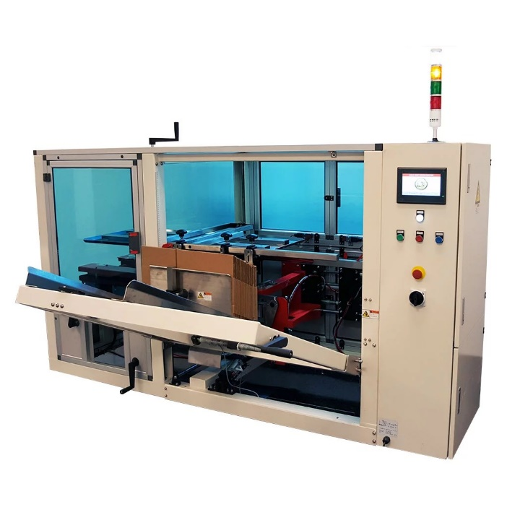

Wexxar Bel252 Case Sealer

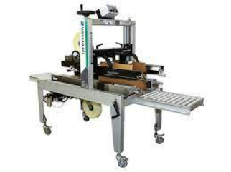

# SYSTEM OPERATION

# Typical Machine Start-Up

Erector:

* Set the case erector power switch to the “on” position
* Run the case erector in automatic “set qty” mode
  + Ensure quantity is set to “1” so the erector can be started/stopped by the main control box
* Clear any faults by hitting the blue reset button
* Load erector with appropriate cases. All cases should be uniformly arranged in the case magazine
* To ensure proper cases, press start to build one box and make sure all case erector adjustments are set correctly

Sealer:

* Bring power to the case sealer by pressing the green start button

Small control box:

* Press “control power on” button

HMI:

* Set the power switch to the “on” position
* Press “control power on” button
* Finally, press “Start System” on the large control box HMI

# Typical System Operation

* Cases are built in the erector then conveyed to the Winpak packer.
* If the sensor at the beginning of the Winpak conveyor is blocked for several seconds, the case erector will create a couple more boxes, then it will wait to build more boxes until the sensor is clear again. There is a delay on this signal so that after the sensor is clear, the erector waits a few seconds before starting a new box. This delay is adjustable in the HMI System Settings.
* After the packer, the filled cases are conveyed into the sealer.
* Boxes enter the customer’s x-ray machine and are rejected as necessary.
* Full, sealed cases accumulate at the end of the line, ready to be palletized.
* If boxes are blocking the final conveyor’s sensor, then each upstream conveyor will stop once a case triggers that conveyor’s sensor.

# HMI Screens

Home screen - From this screen you can start and stop the system, see if there are any active alarms, and navigate to the other screens.

Alarm screen - This screen shows active alarms and when they became active.

Status Indicators - This screen shows which components are active, including the packer, sealer, and erector.

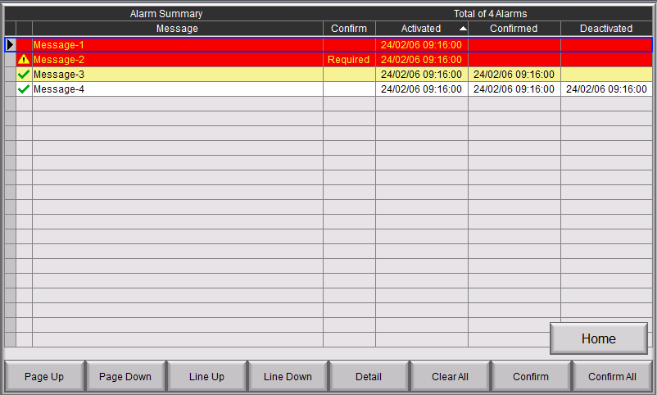

Alarm history - This shows all alarms that have occurred in the system and when they were triggered.

Manual Mode - Control the conveyors manually with this screen after clicking to enable manual mode. Automatic mode needs to be enabled before starting the system again, which can be done from the home screen.

System settings - From this screen, adjust the speed of the first conveyor, the idle time before the system shuts off after a period of inactivity, and the unload time to remove boxes from the last conveyor.

# Case Erector Operation / Adjustments

* Adjustments:
  + Set all orange knobs to the settings indicated on the erector screen “System Settings”. Some minor adjustments may need to be made after setting the knobs to their appropriate settings.
    - Knob 1: This adjusts the width between belts
    - Knob 2: Raises/ lowers height of top plate. Insert a bottom sealed box between the belts to establish the necessary height of the plate: there should be a very small gap between box and the plate.
    - Knob 3: Width of case magazine
    - Knob 4: Height of case magazine. Stand a case up against the brackets on the top plate to determine necessary height of case magazine.
    - Knob 5: Adjusts the arm that each case opens against. This arm should be to the left of the edge between major and minor sides.
    - Knob 6: The horizontal adjustment of the case in relation to the belts. The case should be centered between the belts before the carriage inserts the case into the belts.
  + Carriage: Adjust the knob inside the case erector that carries the carriage’s suction cups. The suction cups should be near the outside edges of the face it is pulling out of the magazine.
  + Case magazine: Move the rightmost two knobs holding the bottom case. The middle knob should be centered in the cut between faces of the case. The knob on the right should be close to the edge of the case.