

ZENITH

Case Strapping Assembly Machine

User’s Manual

Table of Contents

Table of Photos 3

INTRODUCTION 4

Common terminology 4

Safety circuits: 4

Normal Operation: 5

HMI SCREEN DESCRIPTIONS 8

Start Up Screens 8

HOME Screen 9

CYCLE RUN Screen 11

Screen Selector Screen 12

MAINTENANCE Screen 13

TIMERS Screen 14

MANUAL Operation Screen 15

MANAGEMENT Screen/SECURITY 16

FAULT Screens 17

Message displays 19

ADJUSTMENTS BY BOX SIZE 20

LAYOUT DRAWING 21

ELECTRICAL DRAWINGS 22

Miscellaneous PHOTOS 24

INDEX 26

APPENDICES 27

# Table of Photos

Photo 1 - Strapper Operator console 5

Photo 2 - Enable Strapper warm up 5

Photo 3 - Strapper Heating 5

Photo 4- Strapper Ready 5

Photo 5 –Adjusting travel time 13

Photo 6 -Adjustable guide rail 20

Photo 7 - Adjustable guide cam handles 20

Photo 8 - Cycle Start Photoswitch (PS135) 23

Photo 9 - Typical photoswitch quick disconnect 23

Photo 10 - Outfeed Empty Photoswitch (PS139) 23

Photo 11 - Variable Frequency Drive (VFD) for infeed conveyor 24

Photo 12 - EthernetIP programming port for PLC 24

Photo 13- Main Control Panel 24

# INTRODUCTION

This machine is an assembly unit (conveyors and strapping machine) designed to present 5 different packaging arrangements to an automatic strap application machine. Depending on the user selectable packaging recipe, the package will be presented to the strapping machine, and the appropriate number of straps at the correct location will be applied. Then the package will move to the end of the unit.

PLC (programmable logic controller) programming monitors the position of the package using several photoelectric sensors mounted long the conveyors, and determines exactly when strap are to be applied. At the correct timing, signals are sent to the strapping machine to apply the necessary strapping. Additionally, fault conditions are continuously monitored and annunciated by the PLC.

To correctly process the packages, the operator must assure that strapping machine is online and loaded with strapping material and that the correct recipe (corresponding to the size of the package to be processed) has been selected on the human machine interface (HMI)_

## Common terminology

Certain terms, abbreviations are used throughout this manual:

PLC – programmable logic controller

HMI – human machine interface

## Safety circuits:

The conveyor portion of the system is equipped with an emergency stop safety circuit. This circuit is monitored by a discrete safety relay. Two e-stop buttons are located at: 1) the main panel and 2) at the strapping area.

The safety relay provides two channel monitoring of the emergency stop inputs.

## Normal Operation:

To begin processing, the operator will first need to start the strapping machine. First, turn on the disconnect at the strapper control console.

Disconnect

Photo 1 - Strapper Operator console

Photo 2 - Enable Strapper warm up

The strapper HMI will indicate the next task to be accomplished: PUSH Start – this will allow the strapper to begin heating up the sealing heater elements – the stack light on the strapper will have the ORANGE station illuminated at this point. The strapper HMI will change to :

Photo 3 - Strapper Heating

This display will continue until the strapper heaters reach the proper operating condition. Once temperature is reached, the HMI will change to:

Photo 4- Strapper Ready

The strapper is now ready to begin operation. The stack light will have the GREEN station illuminate.

Normal Operation, cont’d

Next from the HMI on the operator station, the operator will place the system in AUTO mode and press the CYCLE START icon. From here the following operations will occur:

When the cycle start photo switch (PS 135) senses an incoming package, both of the conveyors will be started;

The package will move toward the strapping machine; the leading edge of the package will pass the last strap photo switch (PS137) and will continue forward until it reaches the first strap photo switch (PS136);

Both conveyors will be stopped and a signal will be sent to the strapping machine to cause it to apply the first strap to the package. The strapping machine will send an ‘offline’ signal to the PLC;

As the package passed the last strap photo switch, a timer was started in the PLC which accumulated time until the leading edge of the package reached the first strap photo switch (PS136). The distance between these 2 photo switches and the total time it takes for this traverse are used to calculate the package’s travel speed. This speed will be used to determine when to apply any intermediate straps, up to the last strap;

When the strapping machine has completed the strap application, it will return an ‘online’ signal to the PLC. This will restart both conveyors;

Depending on the number of intermediate straps to be applied, timers within the PLC will begin timing how long the conveyors will run until necessary to stop for the next strap application. Once the necessary time has elapsed, both conveyors will be stopped and a signal will be sent to the strapping machine to cause it to apply the next strap to the package. The strapping machine will send an ‘offline’ signal to the PLC;

When the strapping machine has completed the strap application, it will return an ‘online’ signal to the PLC This will restart both conveyors;

The above two steps will continue until the appropriate number of intermediate straps have been applied to the package;

Normal Operation, cont’d

Once the last intermediate strap has been applied to the package, the package will continue to move toward the exit until the trailing edge of the package passes the last strap photo switch (PS136), as that occurs, both conveyors will be stopped and a signal will be sent to the strapping machine to cause it to apply the last strap to the package, the strapping machine will send an ‘offline’ signal to the PLC;

When the strapping machine has completed the strap application, it will return an ‘online’ signal to the PLC This will restart both conveyors;

The package has now been completely strapped and will proceed towards the exit of the system;

When the leading edge of the package reaches the outfeed empty photo switch (PS139) both conveyors will be stopped. Once the package has been removed, the current cycle will be complete and the system will be ready to process the next package as described above,

# HMI SCREEN DESCRIPTIONS

## Start Up Screens

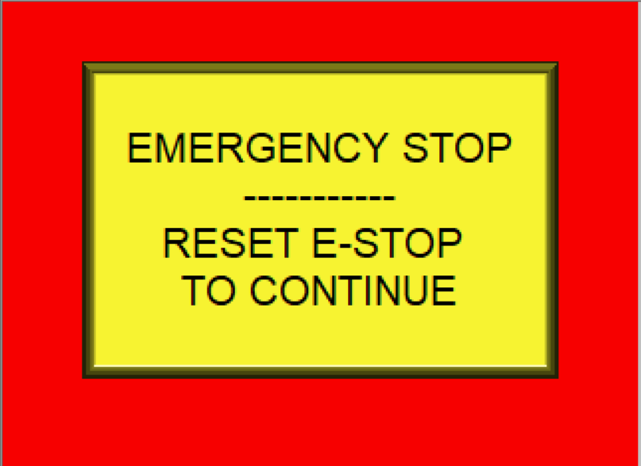

E-Stop Screen

On initial power-up of the machine, after the PLC and the HMI complete their normal start-up activities, the E-Stop screen may be displayed. Before any further operations of the machine may be undertaken, the operator should reset any emergency stop buttons that may have been depressed. Once the Emergency Stop safety circuit is satisfied, the screen will automatically change to:

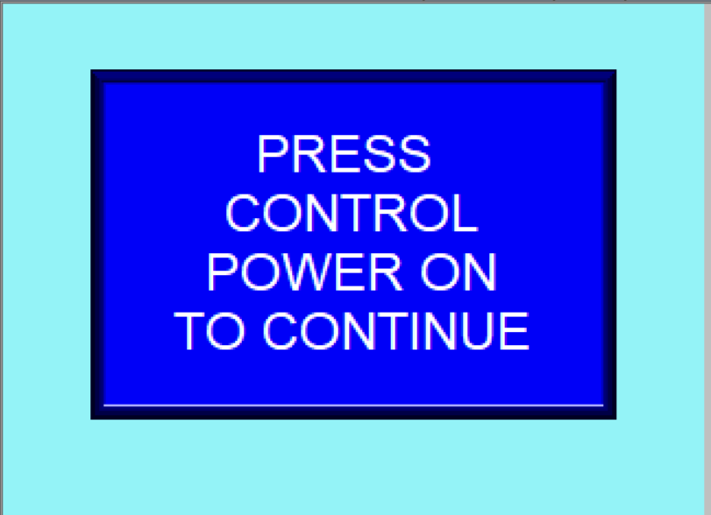

Control On Screen

This will advise the operator to press the Control Power On pushbutton located just below the HMI (Human Machine Interface) on the control panel.

HMI Screen Descriptions, cont’d

## HOME Screen

Once control power has been established, the HMI will automatically display the HOME Screen:

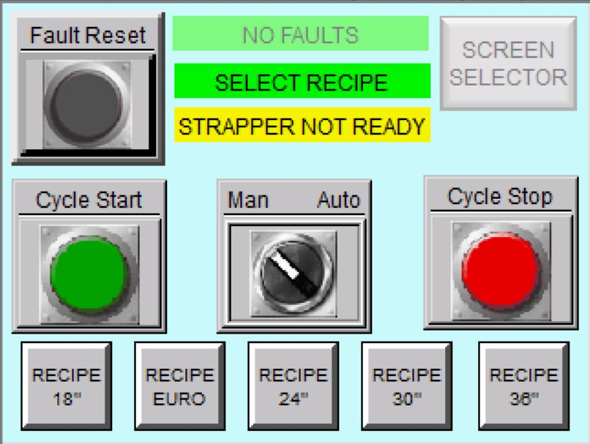

HOME Screen

This is the screen from which normal processing will begin. There are four main areas of this screen: 1) Fault Reset at the upper left, 2) machine status indicators at the center top of the screen, 3) Screen Selector at the upper right, 4) Mode and operation icons in the center of the screen, and 5) Recipe Selection icons along the bottom of the screen.

For normal start up, the operator will be working with items 4 and 5 (above). Depending on the package to be strapped, the operator will need to choose the proper recipe corresponding to the package by touching one of the five icons located along the bottom of the screen. Once this has been done, the machine status indicator area 2 above will change:

Normally, the fault indicator in the machine status area will be indicating:

However, if a fault condition is active, the display will change to:

HOME Screen, cont’d

The third indicator in the machine status area displays the status if the strapper; processing of packages cannot be started until the strapper is on line and ready to strap:

Prior to beginning processing, it will be necessary to get the strapper in the ‘STRAPPER READY’ condition. **The operator is referred to the Side Seal Strapper Operation, Safety and Spare Parts Manual, and should be familiar with the normal and safe operation of the strapper.**

Once the strapper discronnect switch is turned on, the operator should depress the START button to allow the strapper heating element to begin heating. Once these elements have reached the necessary temperature, the strapper will be ready to process, and the STRAPPER READY machine status will be displayed on the Home Screen.

Now from area 4 (above), Mode and operation icons, the operator should touch the MODE icon to switch the system into AUTO:

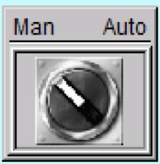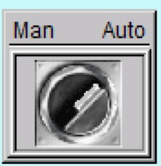

MODE Selection

Next, the operator shoud touch the CYCLE START icon to begin processing.

This will automatically display the CYCLE RUN Screen

## CYCLE RUN Screen

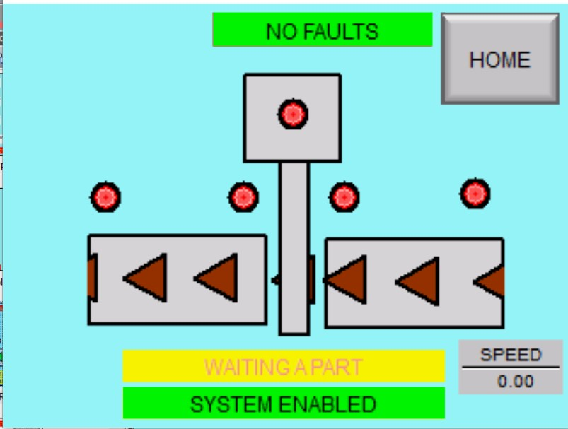

CYCLE RUN Screen

Strapper Online/Offline Status

Cycle start photo switch _PS135 On/Off status

Last Strap photoswitch PS136 On/Off status

Current Condition

Current Travel speed

Conveyor On/Off status

System status

First strap photoswitch PS136 On/Off status

Outfeed Empty photoswitch PS139 On/Off Status

System Fault indicator

The CYCLE RUN Screen provides a graphic display of the real time status of the system. The

Typical On/Off status indicators will show:

Device off

Device on



OFF



ON

Conveyor On/Off status indicator will show:

With the green (ON) icon moving

across the screen.

The System Enabled status occurs whenever: Control power has been established, there are no system faults, the strapper is online, and the CYCLE START button icon on the HMI has been pressed.

There is also a ‘strap applied indicator’ shown at the top left of this screen. It will indicate the current strapping that has been applied to the package.

Note: the operator may only return to the HOME Screen from the CYCLE RUN Screen.

## Screen Selector Screen

From the HOME Screen, the operator may display any of the other screens available (assuming Security for several screens). By touching the Screen Selector button icon at the top right of the screen, the following screen will display:

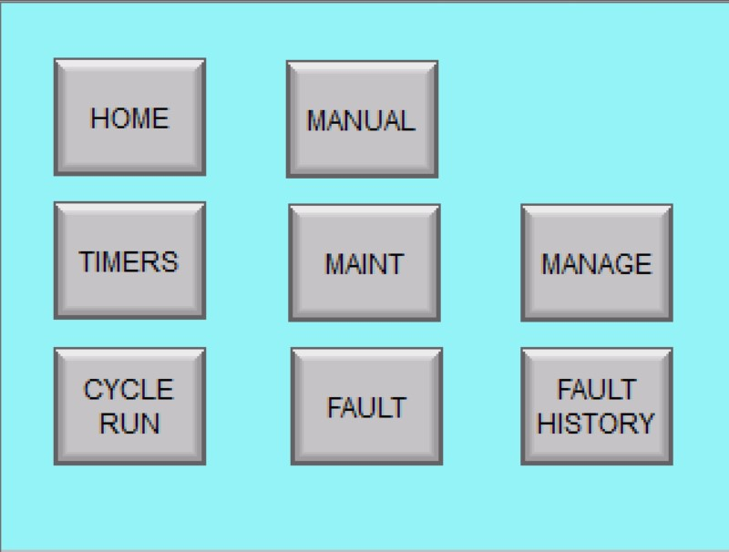

Screen Selector Screen

* requires password to access

By touching one of these pushbutton icons, the corresponding screen will be displayed.

Each of these screens will be discussed below.

## MAINTENANCE Screen

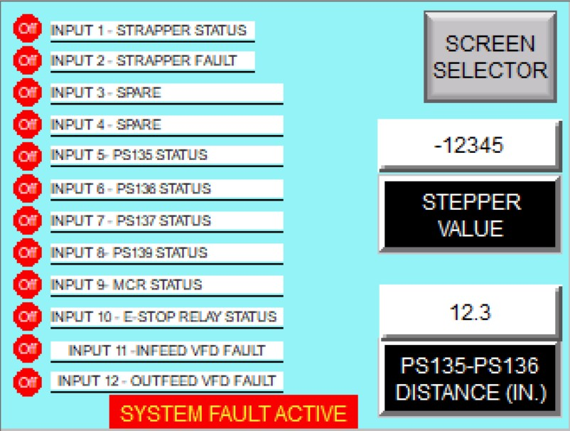

MAINTENANCE Screen

This defines the STEP in the PLC program that is currently being executed. Useful for troubleshooting logic issues

This value is used in the calculation of travel times by the PLC. It is the exact distance between the First Strap photoswitch and the Last Strap photoswitch. Normally, no adjustment is required, but this value should be checked against actual field conditions and adjusted if necessary

Last Strap photoswitch PS137)

Photo 5 –Adjusting travel time

for intermediate straps

First Strap photoswitch (PS136)

The MAINTENANCE Screen is available to the operator with proper security (see MANAGEMENT Screen/Security description for details). Several items are available to assist in troubleshooting tasks: PLC program current step identification, First Strap photoswitch to Last Strap photoswitch distance adjustment, and status of all of the PLC input points are provided.

## TIMERS Screen

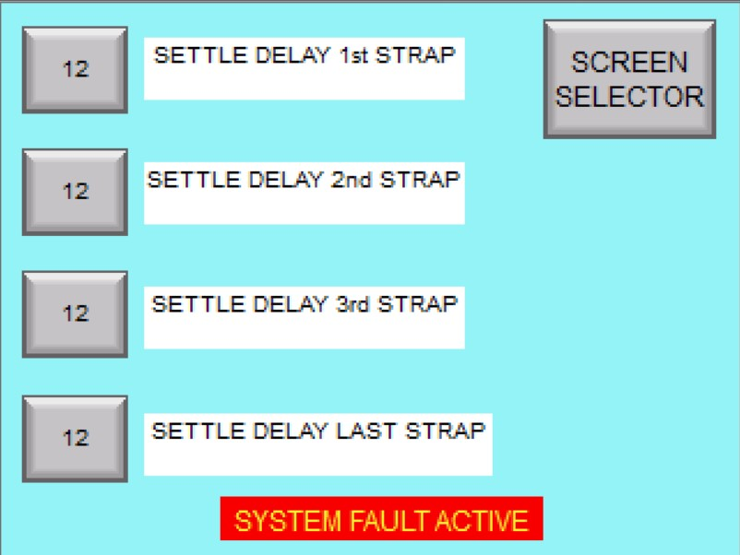

TIMERS Screen

The TIMERS screen is used to provide any additional delay timing between the package stopping and the strap application should it be needed. Normally, no delays are necessary and should not be adjusted unless conditions change in the future operation.

## MANUAL Operation Screen

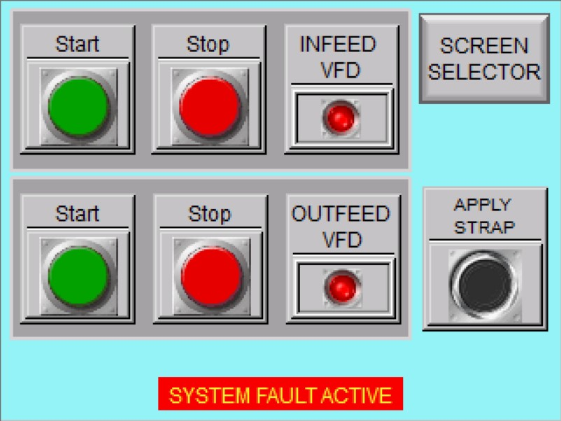

MANUAL Screen

The Manual Screen is provided to allow manual start/stop operation of the conveyors and the manual application of a strap. This screen may be accessed using the Screen

Selector icon form any screen; additionally, it will be automatically displayed when the MODE Selector on the HOME Screen is switched from AUTO to MAN.

Pushbutton icons for Start and Stop as well as status indication is provided for the two conveyor sections. NOTE: the strapper must be off line to operate the conveyors manually.

The APPLY STRAP pushbutton icon will trigger the strapper to apply a strap.

## MANAGEMENT Screen/SECURITY

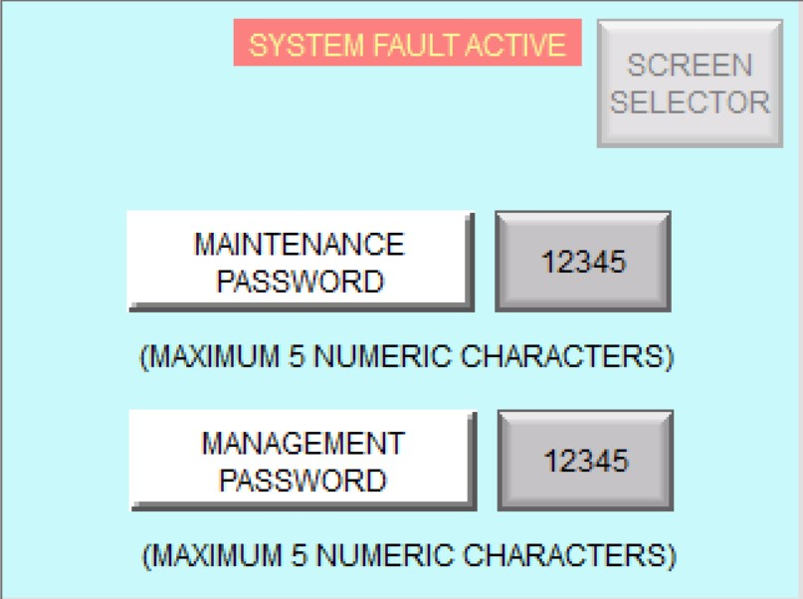

MANAGEMENT Screen

Security by use of password protection for certain screens within this project is controlled by the use of the Management screen. Using this screen, the manager controls the passwords used by both the manager and the maintenance operator. The manager has access to all of the screens in the project. The maintenance operator has access to certain screens necessary to maintenance procedures, but not necessary for normal operations of the equipment,

Initial passwords for both levels of protection are initially set to 0 (zero). The manager should access this screen and set and record appropriate passwords for each user. Passwords are limited to a 10 character, numeric value.

When attempting to enter a protected screen, the following pop-up will appear:

Simply use the keypad to enter the necessary password and press the ENT pushbutton icon to advance to the desired screen.

After using the keypad to enter the password, press here to advance to the desired screen

**NOTE: Be Sure to record any password changes for future reference**

## FAULT Screens

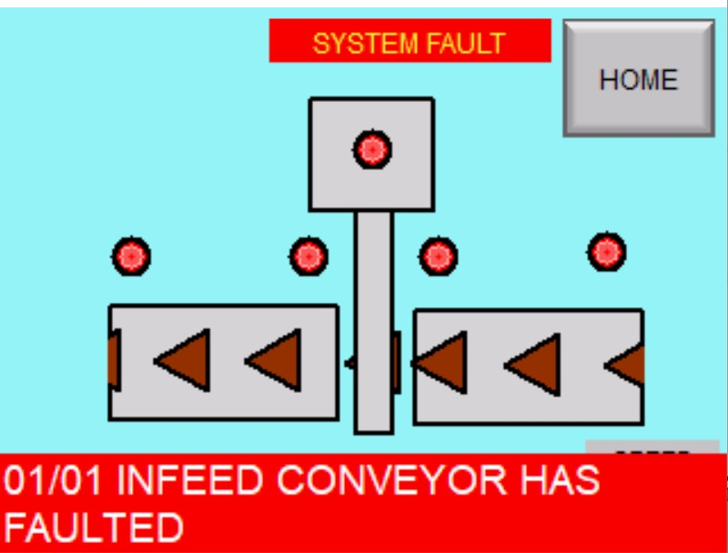

FAULT BANNER

A FAULT is any abnormal condition of the system that will stop processing and require operator intervention to correct. When a fault occurs, a banner will appear at the bottom of the current screen indicating the fault condition.

The operator should access the HOME Screen in order to attempt to reset the fault condition by pressing the FAULT RESET pushbutton icon.

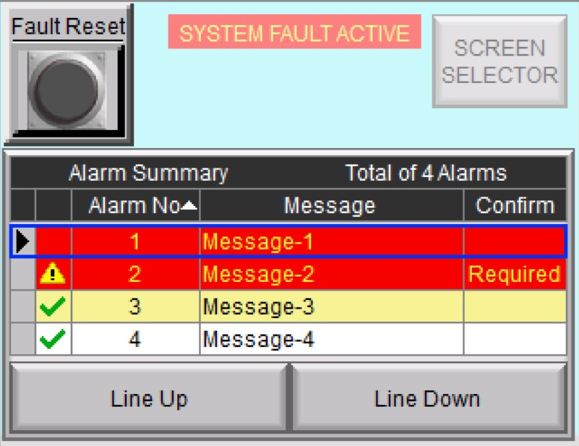

FAULT Screen

Alternately, the operator may use the Screen Selector to Access the FAULT Screen.

The fault screen will provide a list of all of the active fault conditions that exist. The operator should take corrective action to address the condition, then press the FAULT RESET pushbutton icon to clear the fault condition, When the condition has cleared, it will be removed from the FAULT Screen list.

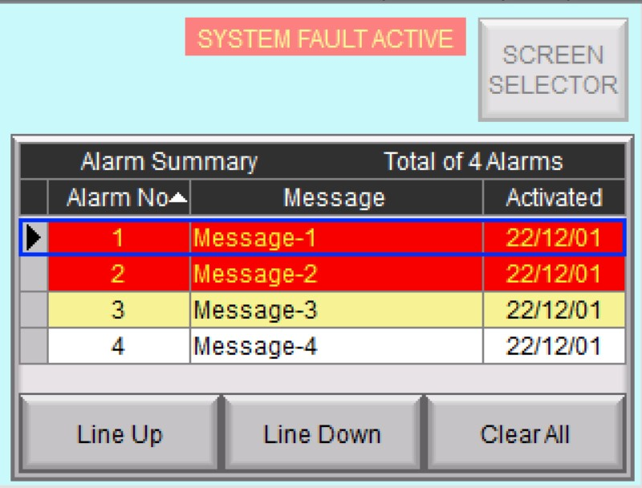

FAULT HISTORY Screen

The FAULT HISTORY Screen is password protected. It provides a list of all of the faults that have occurred since the last time the list ws cleared. Use the CLEAR ALL pushbutton icon to clear the list.

FAULT Screens, cont’d

A list of the faults to which the system is responsive is shown in the table below.

**FAULT TABLE**

|  |  |
| --- | --- |
| **FAULT NUMBER** | **DESCRIPTION** |
| FAULT1-INFEED CONVEYOR | INFEED CONVEYOR HAS FAULTED |
| FAULT2-OUTFEED CONVEYOR | OUTFEED CONVEYOR HAS FAULTED |
| FAULT3 STRAPPER4 | STRAPPER HAS FAULTED |
| FAULT4 - HMI HEATERBEAT | FAULT 4 - HMI HEARTBEAT HAS STOPPED |
| FAULT5_PS136ON | FIRST STRAP PHOTO SENSOR (PS136) IS ON INCORRECTLY |
| FAULT6_PS137 ON | LAST STRAP PHOTO SENSOR (PS137) IS ON INCORRETLY |
| FAULT7 - PS139ON | PS139 HAS BEEN BLOCKED FOR TOO LONG |

## Message displays

There will be times when the operator attempts to perform an operation and is met with a not successful outcome. Several message screens have been provided to assit the operator in understanding what has occurred and what needs to happen to provide the expected outcome. These are shown below.

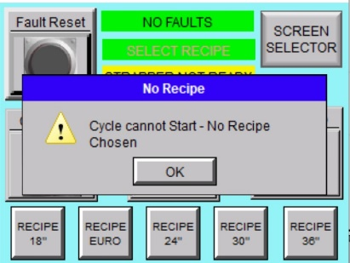

MESSAGE 1

If the operator attempts to start a cycle before a recipe has been selected, Message 1, shown at left will pop-up on the HOME Screen. The operator should press the OK icon, and select the appropriate recipe before attemting to run a cycle.

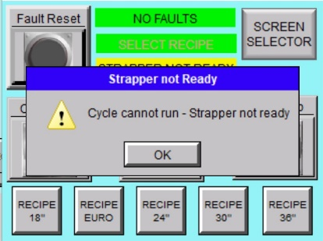

MESSAGE 2

If the operator attempts to start a cycle before the strapper is online, Message 2, shown at left will pop-up on the HOME Screen. The operator should press the OK icon, and place the strapper online before attemting to run a cycle.

When attempting manual operation of the system conveyors, the strapper will need to be taken offline, otherwise Message 3, shown at the left will be dispaleyd on the MANUAL Screen. The operator should take the strapper offline before continuing.

MESSAGE 3

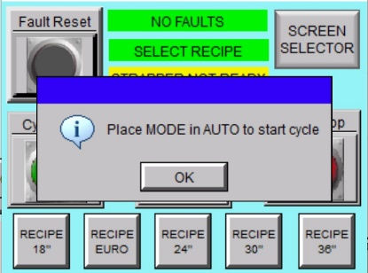

MESSAGE 4

If the operator attempts to start a cycle before THE mode Slector Switch iocn has been placed in the AUTO position, Message 4 , shown at the left, will be displayed on the HOME Screen. The operator should press the OK icon, and place the MODE Selector in AUTO before attemting to run a cycle.

# ADJUSTMENTS BY BOX SIZE

The guide rail pictured in Photo 5 is used to passively justify incoming boxes against the side of the conveyor.

– Adjustable guide rail

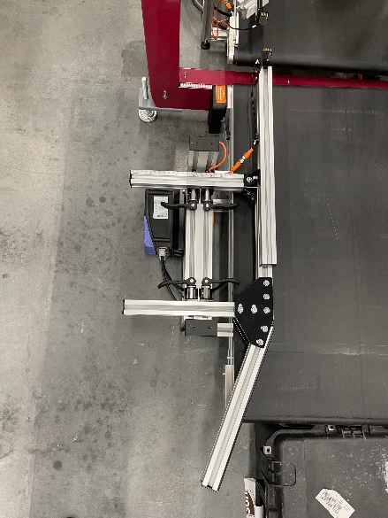

Photo -Adjustable guide rail

To adjust this guide for the different sized boxes, the cam handles must be loosened to move the guide, aligned to the desired box size, and retightened. To loosen the handles, release handle and turn counterclockwise. To tighten, turn clockwise until the handle comfortably and securely clamps in the desired poisiton. The screw on the inside (pictured in Photo 6, below) may be loosened or tightened to allow for minor adjustments.

Adjustable guide cam handles

Photo - Adjustable guide cam handles

# LAYOUT DRAWING

# ELECTRICAL DRAWINGS

# Miscellaneous PHOTOS

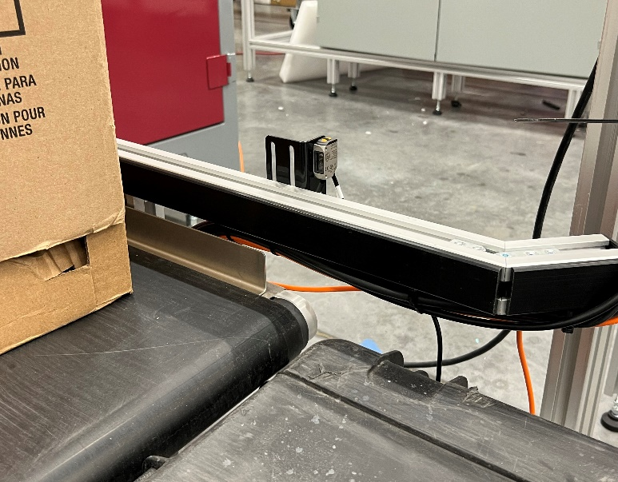

Photo 8 - Cycle Start Photoswitch (PS135)

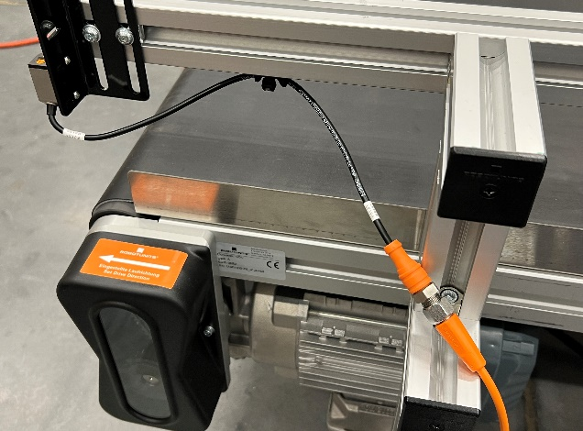

Photo 9 - Typical photoswitch quick disconnect

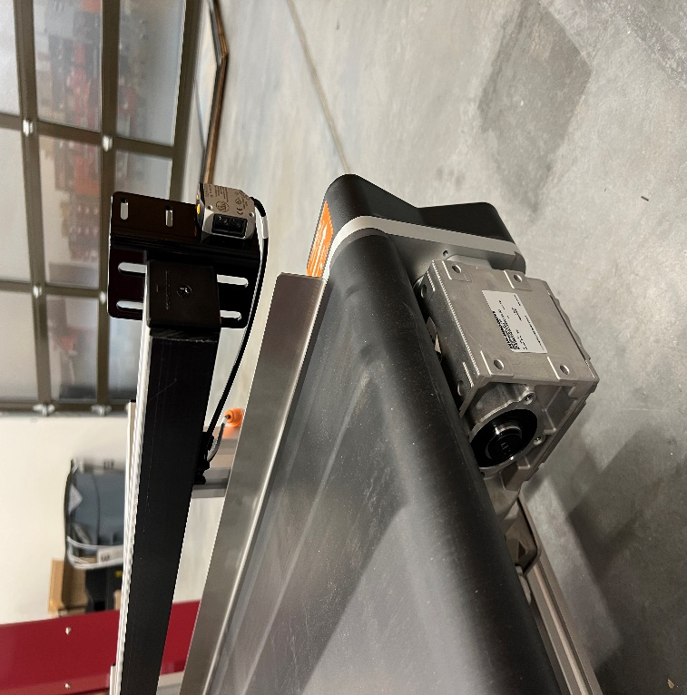

Photo 10 - Outfeed Empty Photoswitch (PS139)

Miscellaneous PHOTOS, cont’d

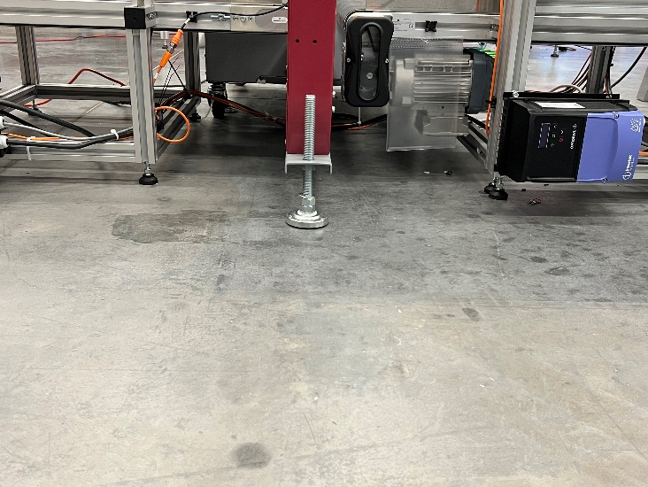

Photo 11 - Variable Frequency Drive (VFD) for infeed conveyor

Strapper support leg

VFD (Variable Frequency Drive) for infeed conveyor

Emergency Stop Pushbutton

Control Power Pushbutton

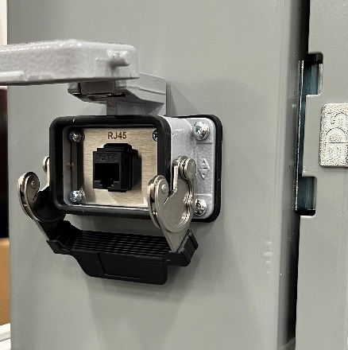

Photo 12 - EthernetIP programming port for PLC

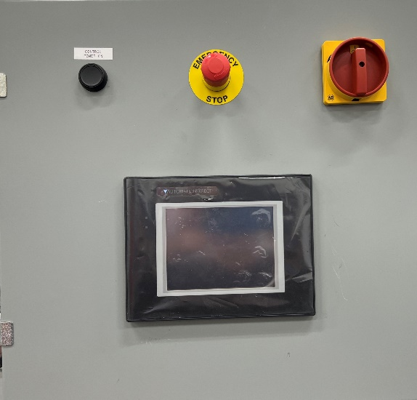

Photo 13- Main Control Panel

HMI (Human Machine Interface

Disconnect

# INDEX

FAULT, 17

FAULT Screens

FAULT Screen - FAULT HISTORY Screen, 17

**FAULT TABLE**, 18

HMI – human machine interface, 4

HOME Screen, 9

keypad, 16

MAINTENANCE Screen, 13

MANAGEMENT Screen/SECURITY, 16

MANUAL Operation Screen, 15

Message 1, 19

Message 2, 19

Message 3, 19

Message 4, 19

Message displays, 19

password protection, 16

PLC – programmable logic controller, 4

Start Up Screens, 8

TIMERS Screen, 14

two channel monitoring, 4

Variable Frequency Drive (VFD) for infeed conveyor, 3

# APPENDICES

Strapper User’s manual – given to customer on 1/19/23.

Conveyor VFD manual – given to customer on 1/19/23.